**Hands-on Learning Module – Creating the VRG (View Ridge Gallery) database.**

**We are going to work with Microsoft SQL Server Management Studio and create a database called VRG.mdf. It is a database that stores data regarding artists, their work, as well as the customers and their transactions or purchases.**

**We are going to create the following tables: ARTIST, WORK, CUSTOMER, TRANS, as well as the CUSTOMER_ARTIST_INT.**

**Additionally, we will create a database diagram of the VRG database tables, as well as populate the tables with the data.**

**Please note that the instructions below are in general form and for more detailed instructions, please review the document attached to the First Set of Assignments – M10A_KROE2749_15_SE_C10A.pdf (starting on page 59).**

**Use the Start Menu and select Microsoft SQL Server Management Studio**

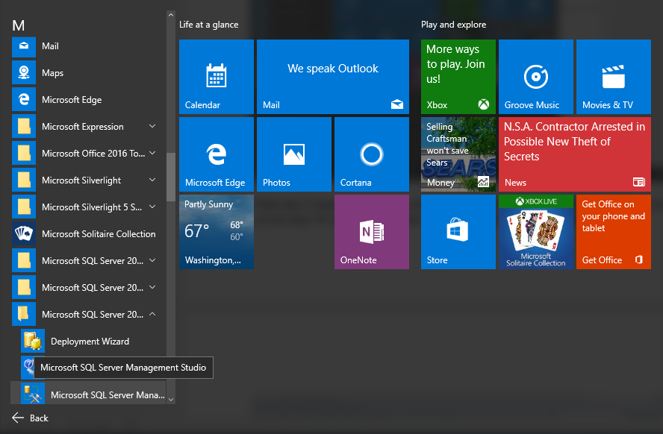

**Click the Connect button to connect to Microsoft SQL Server. Your screen may be slightly different than mine in terms of the Server name and other items.**

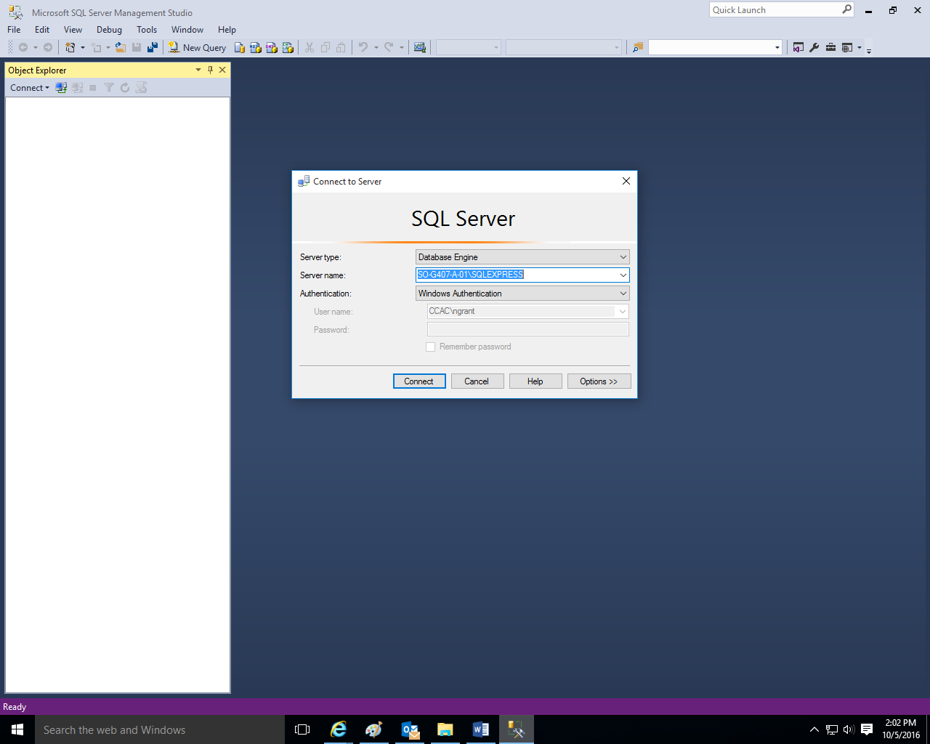

**Right-click on the Databases folder and then left-click on New Database.**

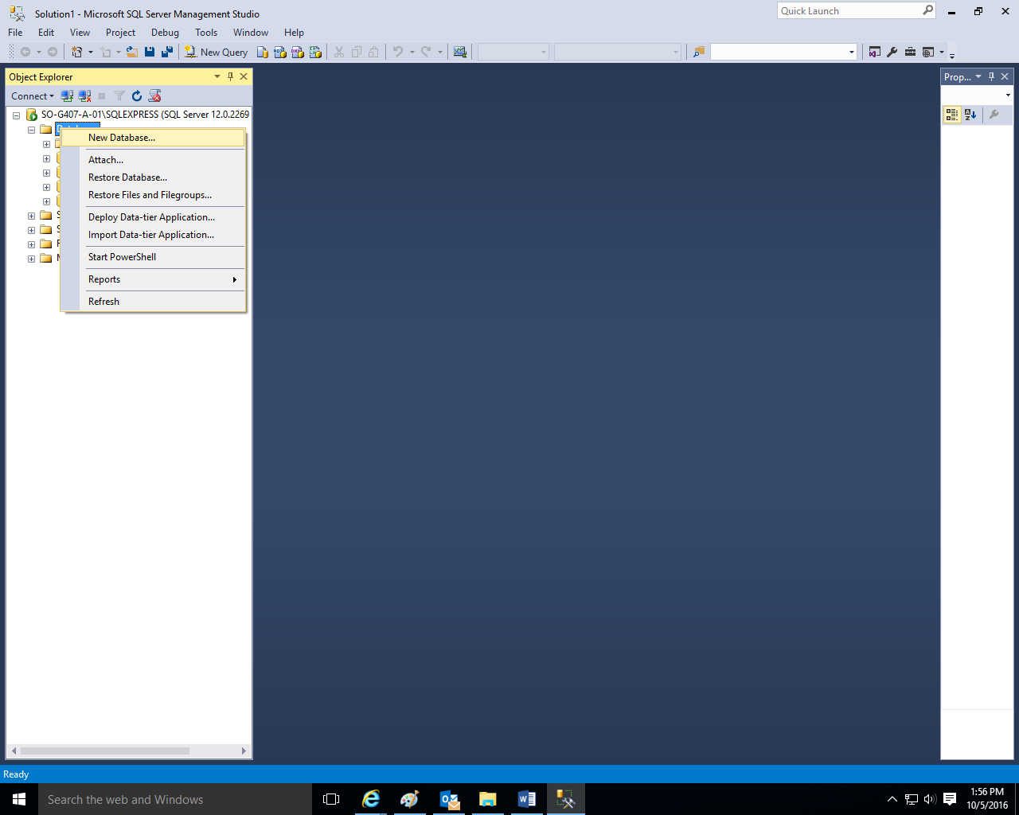

**Type VRG as the database name and click the OK button.**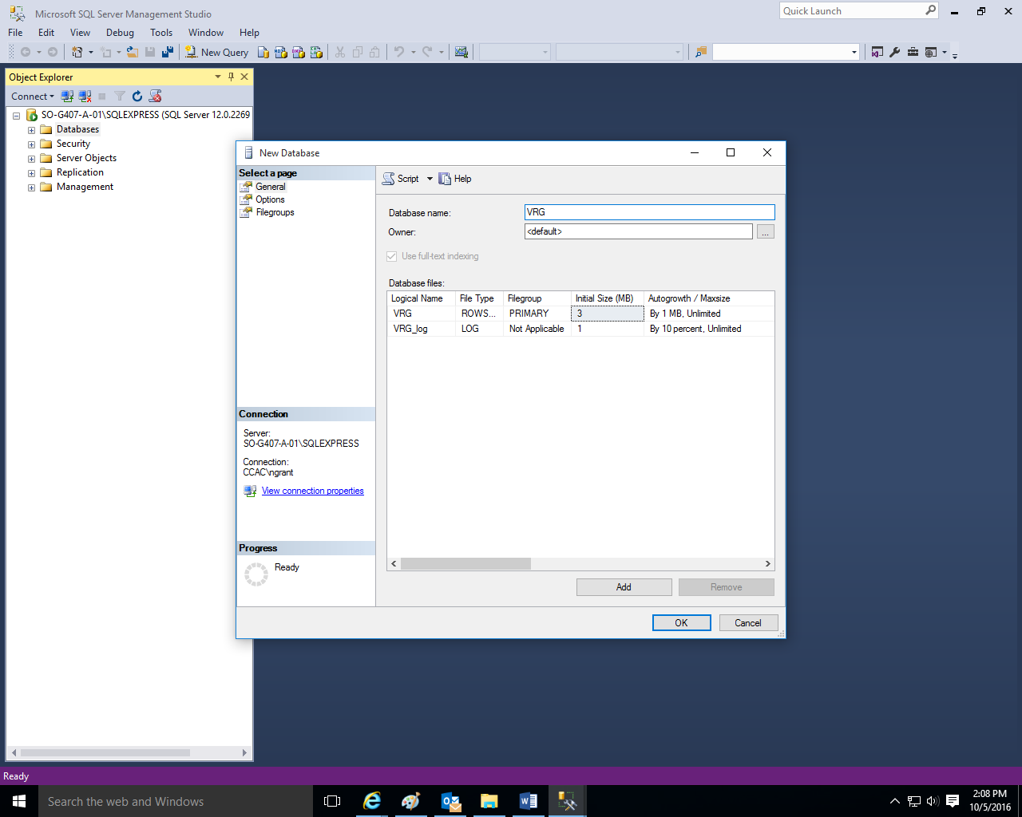

**Once you do this, the system will create your VRG database with an .mdf extension. It will also create a VRG.log system file.**

**Click the + sign next to the Databases Folder to view all of the created databases.**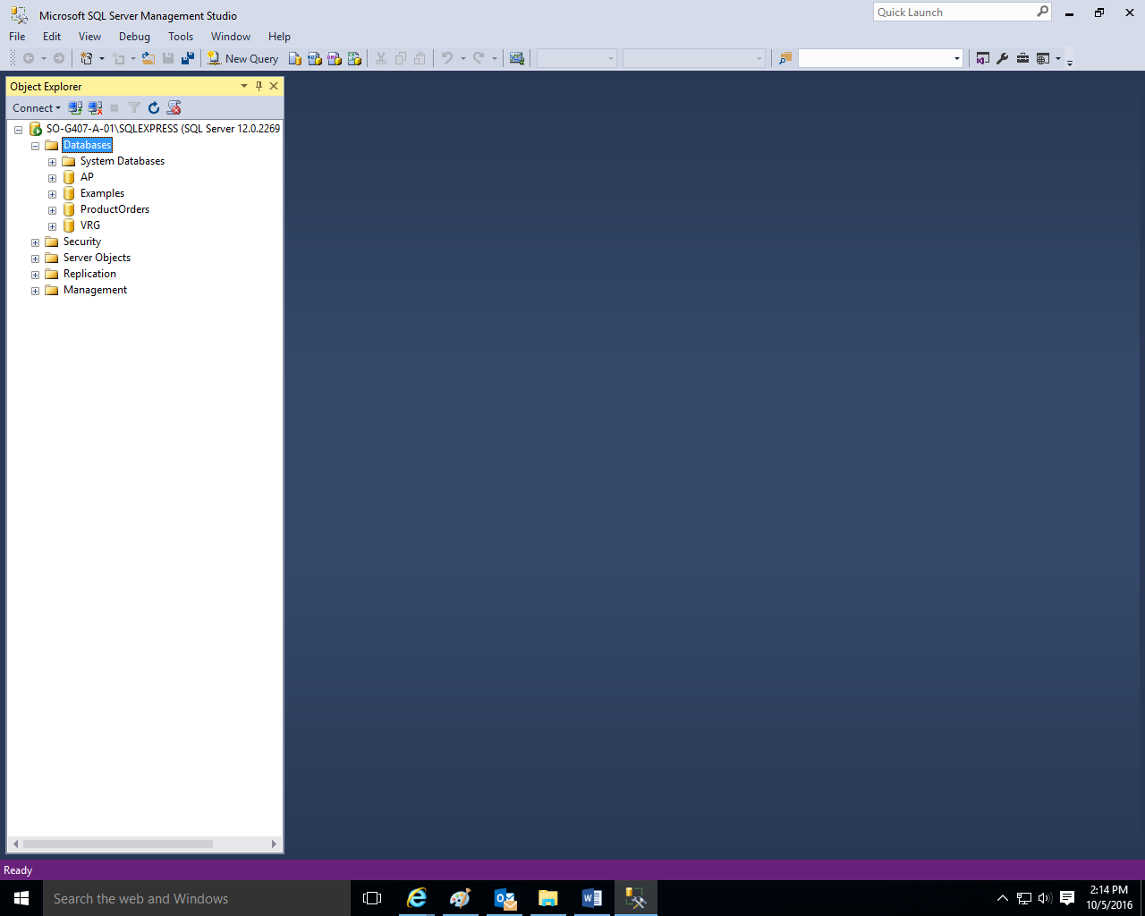

**Click the + sign next to the VRG database.**

**Download and save the two .sql files (DBP-e15-MSSQL-VRG-Create-Tables.sql and DBP-e15-MSSQL-VRG-Insert-Data.sql) from the First Set of Assignments at our course at** [**https://courses.ccac.edu**](https://courses.ccac.edu)

**As noted in their filenames, the DBP-e15-MSSQL-VRG-Create-Tables.sql file will create all of the table structures for the VRG database, and the DBP-e15-MSSQL-VRG-Insert-Data.sql file will populate the data into the tables.**

**Use the File, Open, File commands and open the DBP-e15-MSSQL-VRG-Create-Tables.sql file.**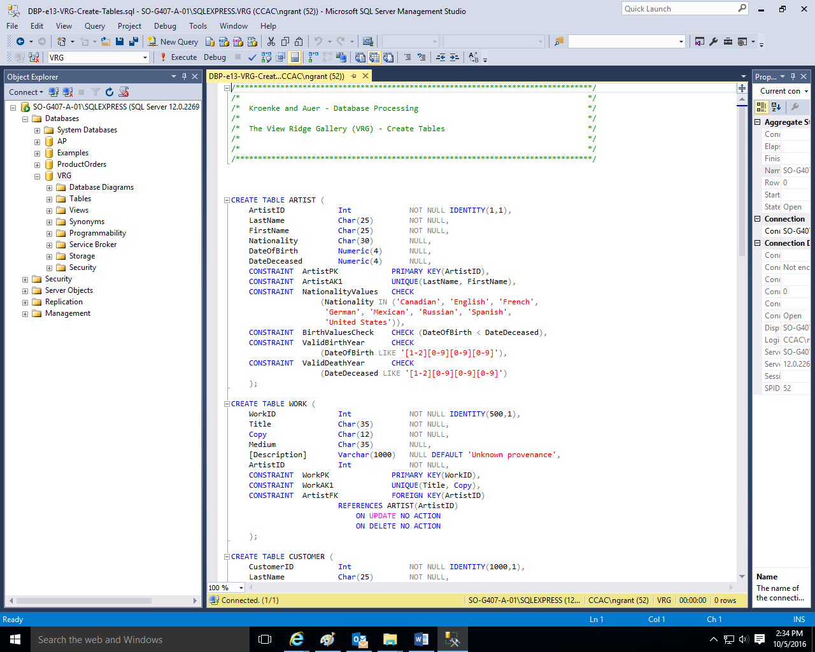

**Click the Execute command to create the table structures.** 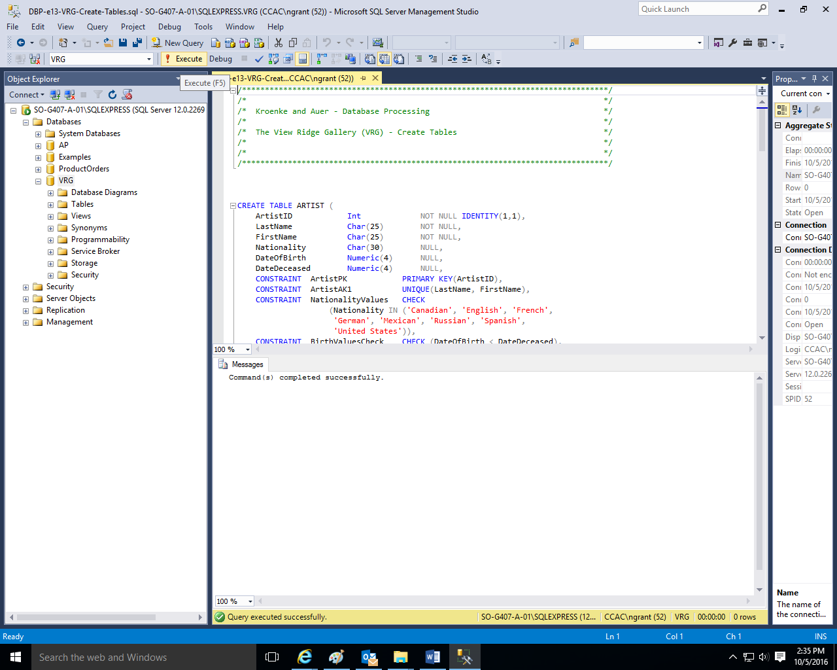

**The system should indicate that the Command(s) completed successfully in the Messages tabbed window.**

**Click the + sign next to the tables folder in order to view the created table structures (dbo.ARTIST, dbo.CUSTOMER, dbo.CUSTOMER_ARTIST_INT, dbo.TRANS, and dbo.WORK). dbo stands for database owner.**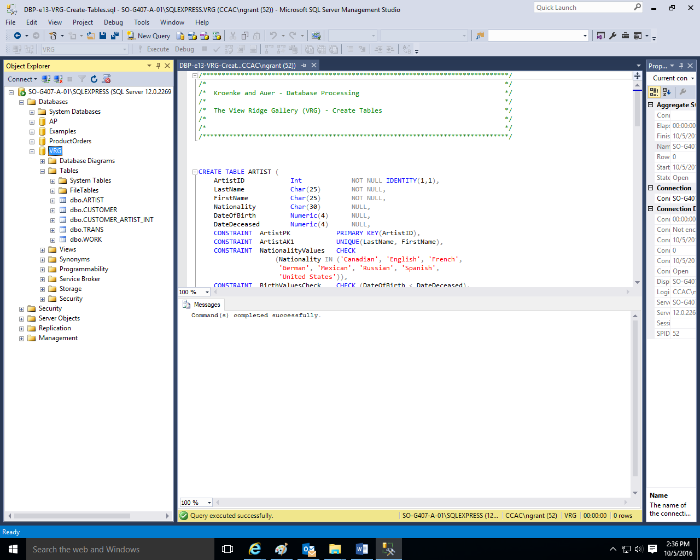

**Right-click on the Database Diagram and then left-click on New Database Diagram.**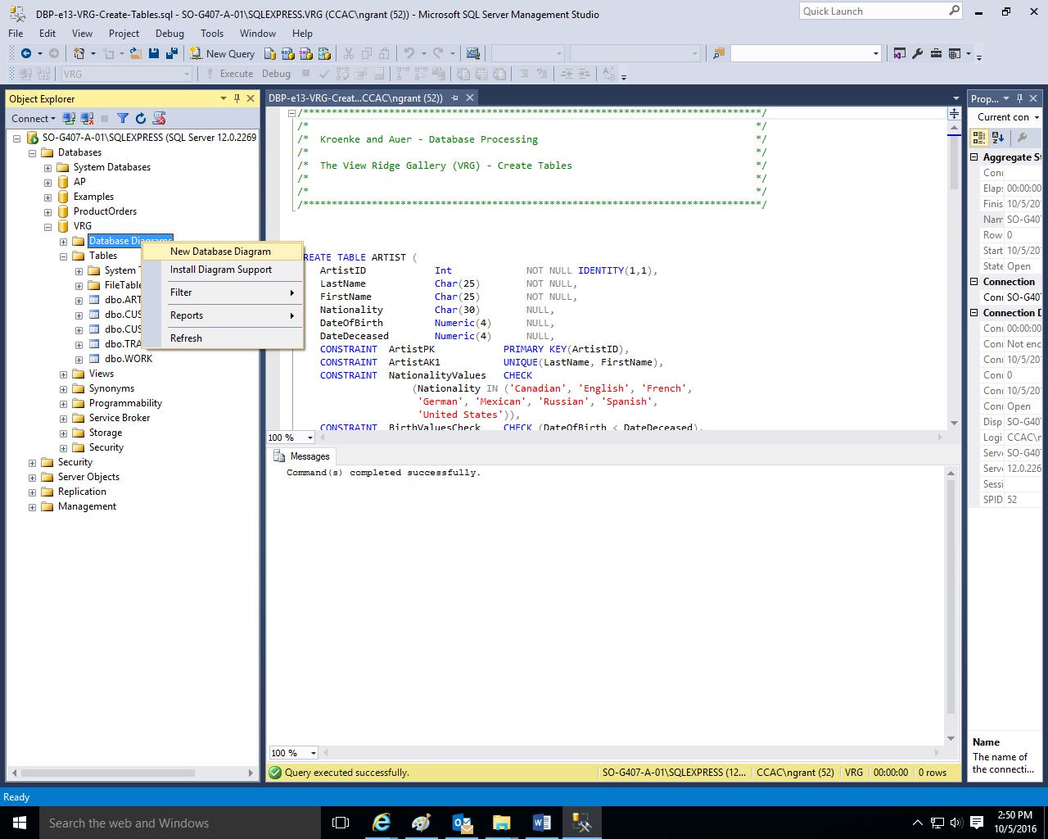

**Click yes to create them.**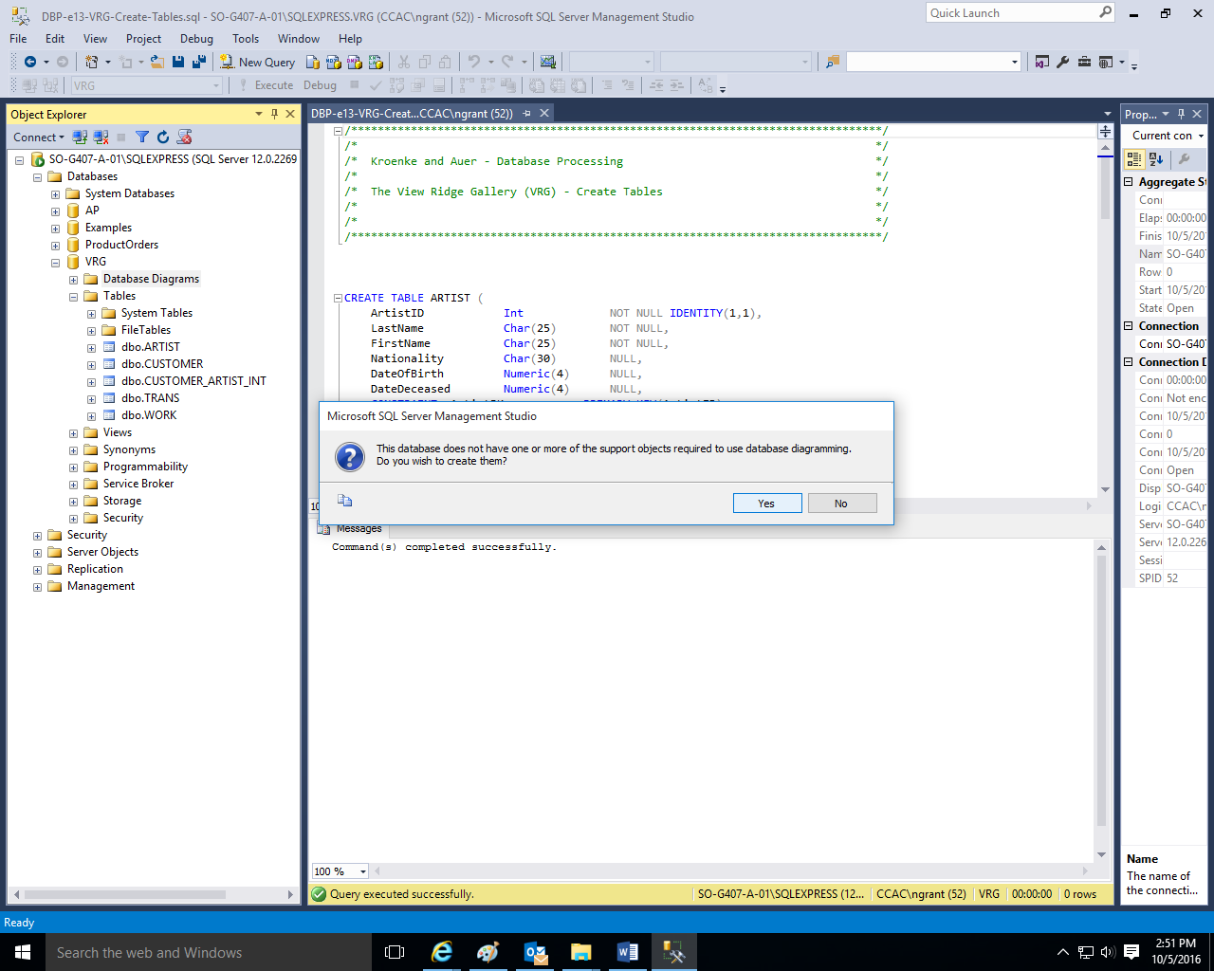

**Click each table and click the Add button to add them to the diagram screen and use the Close button.**

**Create the database diagram as shown below. Be sure to align the keys among the tables as well.**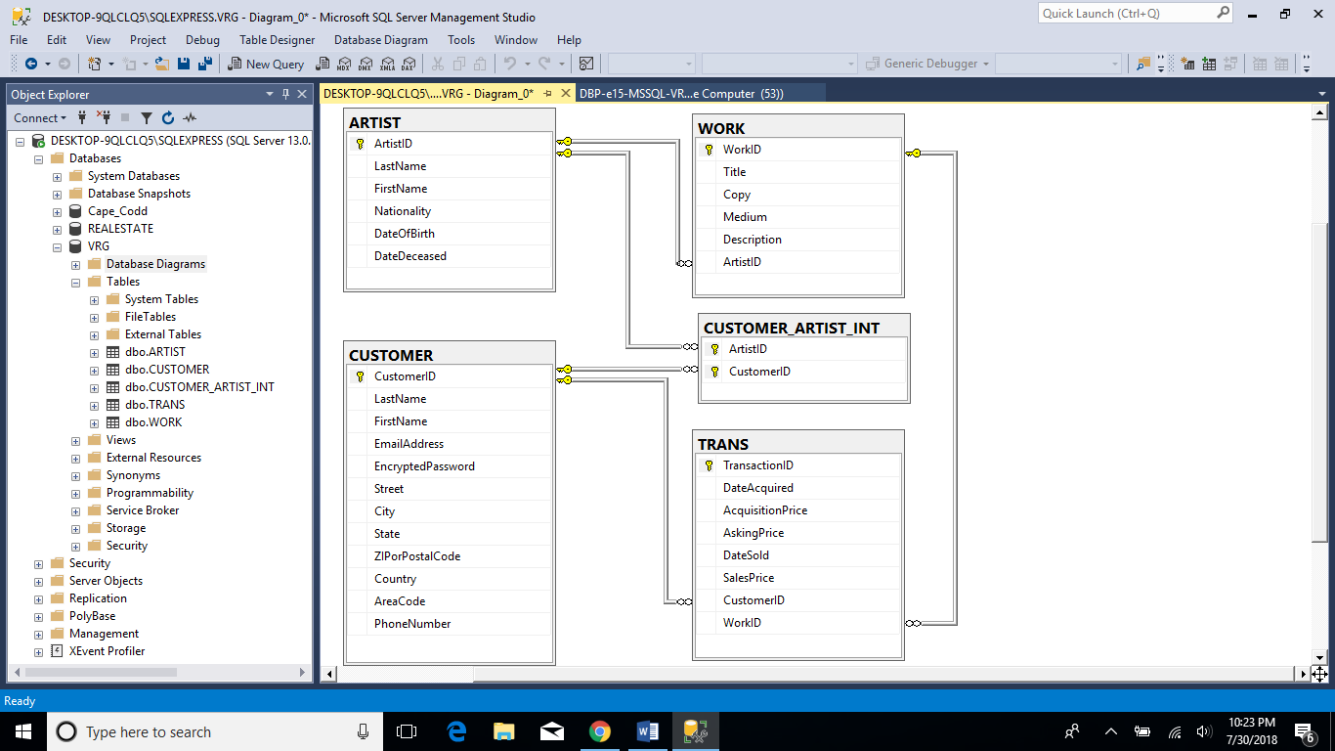

**Click the File, Save Diagram-0 and then save the diagram as VRG-Database-Diagram and click the OK button to save the diagram.**

**Use the File, Open, File commands and open the DBP-e15-MSSQL-VRG-Insert-Data.sql file.**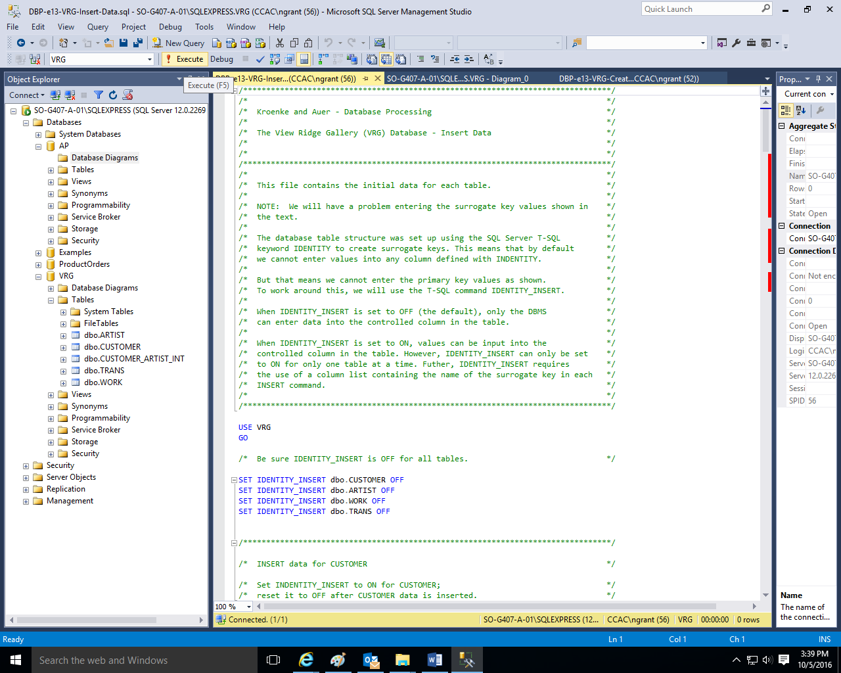

**Click the Execute command to populate or insert the data into the tables.**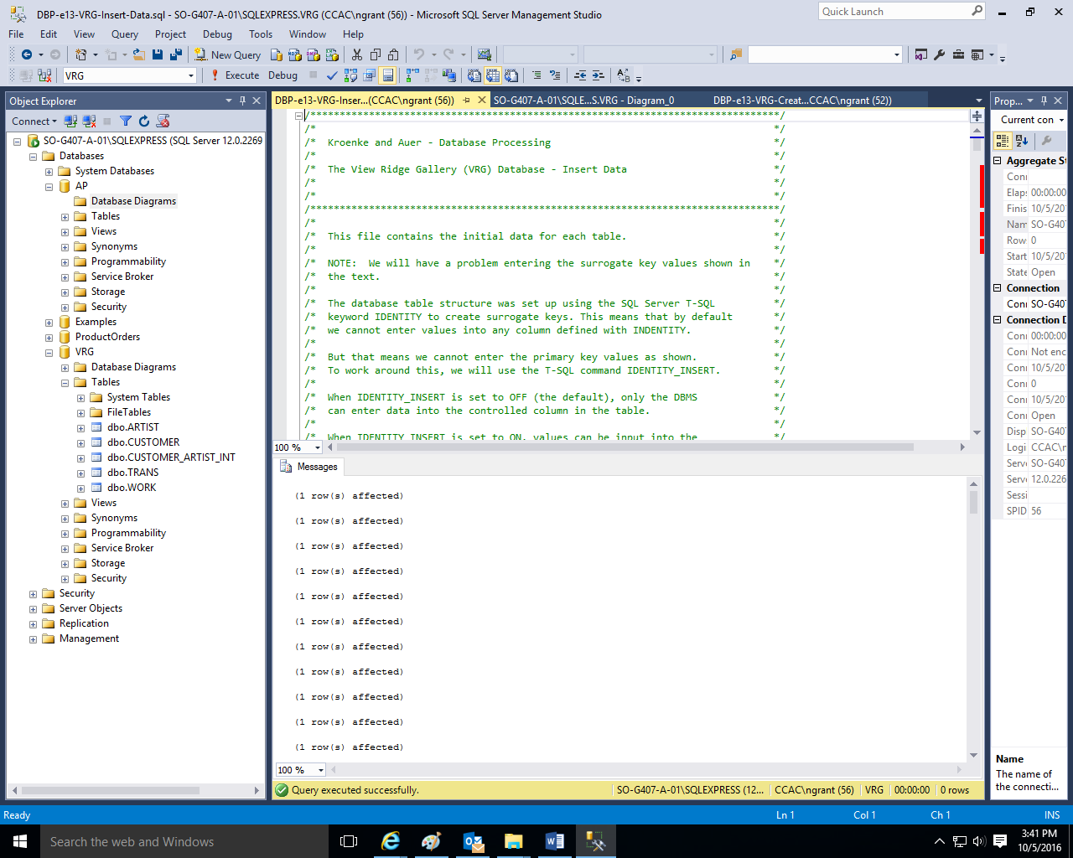

**The system should indicate that the Command(s) completed successfully in the Messages tabbed window.**

**Use the File, New, Query with Current Connection in this case the VRG database) in order to create four simple queries (from each table).**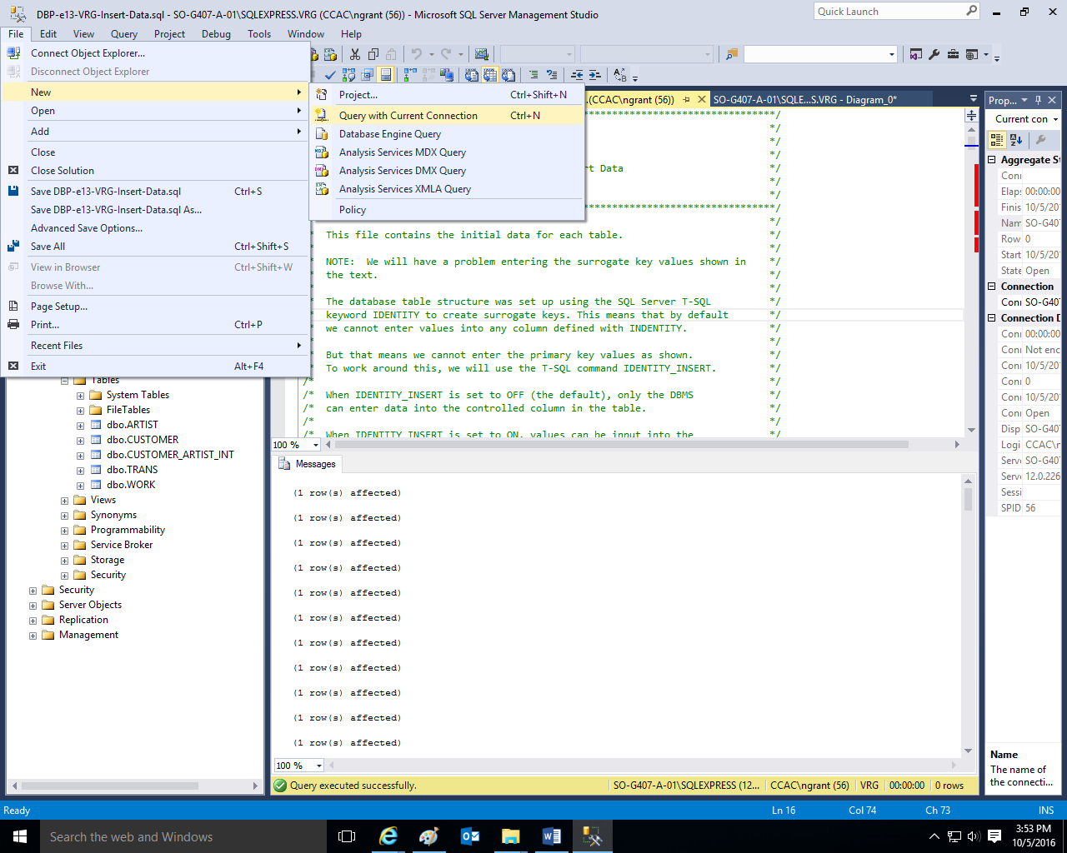

**Type the four simple Select queries in order to see the data contained in the ARTIST, CUSTOMER, TRANS, and WORK tables. Highlight the first query and use the Execute button to view the results in the Messages Tabbed Window. Repeat the highlighting process and use the Execute button to review the results of the other queries.**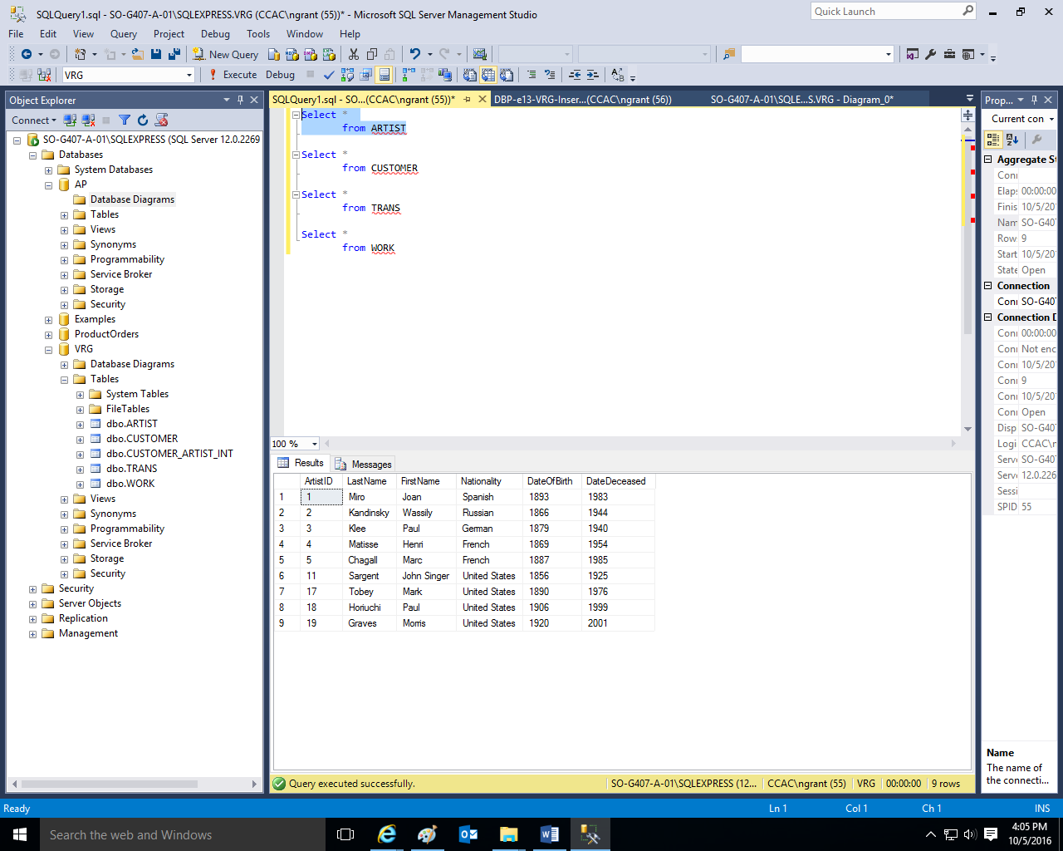

**Use the File, Save As commands and save the query as VRG Simple Queries.**

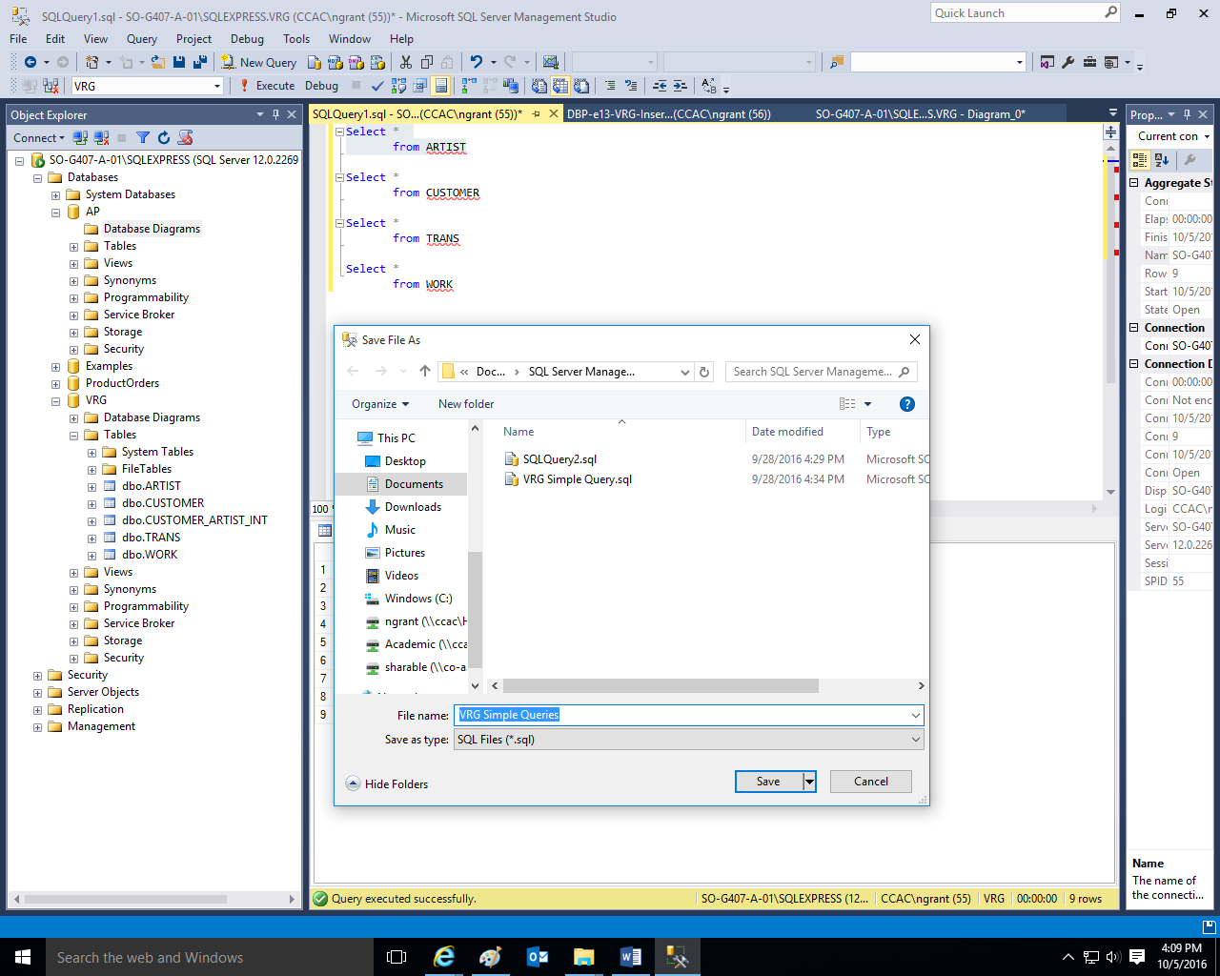

**The software will add a .sql extension to the file.**

**Use the File, Exit commands to exit out of Microsoft SQL Management Studio or continue with step 7 below.**

**As time permits, students may want to research and explore other items such as reviewing relationships in the tables, creating indexes, creating views, backing up and restoring databases, using designer windows, importing data from other Microsoft products, such as Microsoft Excel, using Transact-SQL statements, creating stored procedures, creating triggers, as well as working with database security settings.**